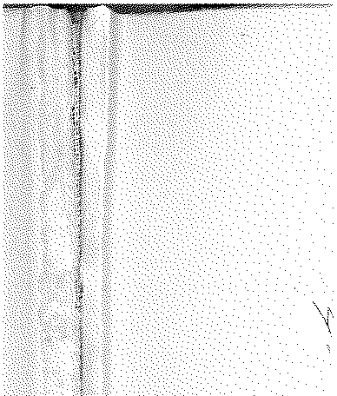

# Annual Vol ume of

TH E LAW S



# of Western N igeria

1962

## containin g

the Laws of Western Nigeria

and subsidiary legisla tion made thereunder



LOS ANGELES COUNTY

LAW LIBRARY

***B 378***

W.N.L.N. 136 of 1962.

W.N.L.N. 385 of 1960.

* + - 1. **181 of 1962**

*The Local Government Law (Cap. 68)*

THE CONTROL OF DRUMMING ADOPTIVE BYE-LAWS ORDER, 1956

ABEOKUTA URBAN DISTRICT COUNCIL DATE OF COMMENCEMENT: 21ST JUNE, 1962

**Notice is hereby given that in exercise of the powers conferred upon him** by the Abeokuta Urban District Council (Dissolution) (Amendment) (No. 3) Order, 1962, and by section 83 of the Local Government Law, Mr Percy **Dyson, the Administrator in respect of the Abeokuta Urban District Council,** has resolved on the 6th day of June, 1962, that the First and Third Schedules to the Control of Drumming Adoptive Bye-laws Order, 1956 (Abeokuta Urban District Council) be amended:

* + - * 1. by adding to the First Schedule the words­

**"Seli-Moda** Bembe **Angoso"**

* + - * 1. by adding to the Third Schedule the words-

***Descriptt'on***

*of Drums* Seli-Moda Seli-Moda Bembe ...

Bembe ...

Angoso ...

**Angoso ...**

*Period*

For any period between 6 a.m. and 6 p.m. **For any period between 6 p.m. and 6 a.m.** For any period between 6 a.m. 'llld 6 p.m. **For any period between 6 p.m. and 6 a.m. For any period between 6 a.m. and 6 p.m. For any period between 6 p.m. and 6 a.m.**

### Fees

*s d*

10 0

15 0

10 0

15 0

10 0

15 0

o. OLUWADARE,



*Secretary*

Abeokuta, 6th June, 1962.

**P. DYSON,**

### Admini.strat(lT'